**Effect of Deviatoric Stress on Permeability and Velocity**

**Rhett and Teufel, 1992**

*North Sea Sandstones*

Underhydrostatic loading (theconventional testprocedure followed by the petroleum industry) the permeability of the sandstone decreases with increasing effective stress. However, in sharp contrast, under non-hydrostatic loading, in which the stress path is K = 0.5 or lower, the permeability increases with increasing effective stress.Test results indicate that the increase in permeability is greater for stress paths that have lower stress ratios and correspondingly larger incremental increases in shear stress.

K = S3/S1

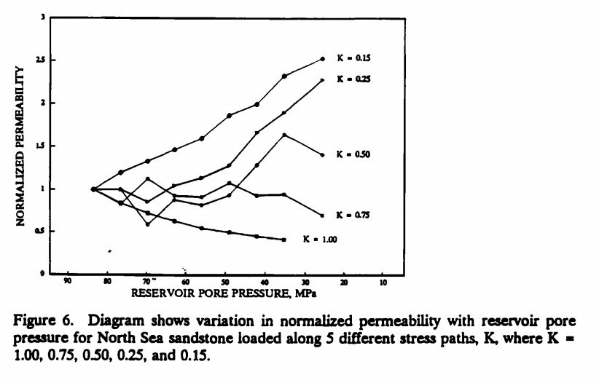

Under hydrostatic loading, the permeability of the sandstone decreases with increasing effective stress. However, in sharp contrast, under non-hydrostatic loading, in which the stress path is K = 0.5 or lower, the permeability increases with increasing effective stress. Test results indicate that the increase in permeability is greater for stress paths that have lower stress ratios and correspondingly larger incremental increases in shear stress.

**Korsnses et al., 2006**

*Chalk*: In the deviatoric tests the increasing stress is applied parallel to the flow direction, and the  
change in the permeability is very small, nearly within the uncertainty for both the mid-section and the overall permeabilities. This observation is in line with previously published data on weakly cemented sandstones. Bruno et al. (1991) showed that the permeability reduction was relatively small when the stress was applied parallel to the flow direction, but the same stress magnitude was much more significant when applied perpendicular to the direction of flow.

*Sandstone*: During the hydrostatic test, the permeability decreased as the average effective stress increased. The permeability during the deviatoric test remained quite constant.

**Shao et al., 2005**

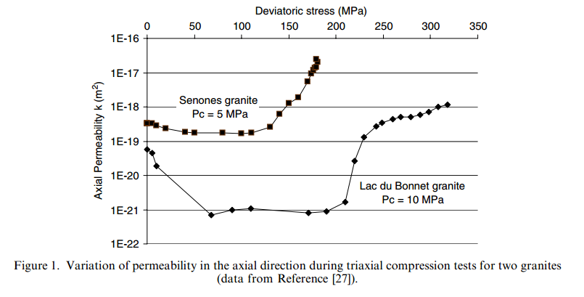

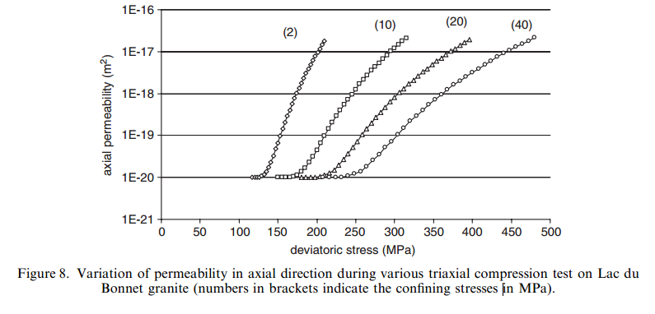

**Bronu et al., 1991**

There is a general consensus that compression of microcracks and high aspect ratio pores dominates stress-induced permeability reduction in low permeability rocks. A few researchers, including Snow (1969) and Sayers (1990), attribute permeability anisotropy in fractured rock to preferential closing of cracks aligned perpendicular to the maximum stress direction.

